Given the array houses and an integer k. where houses[i] is the location of the ith house along a street, your task is to allocate k mailboxes in the street.

Return the **minimum** total distance between each house and its nearest mailbox.

The answer is guaranteed to fit in a 32-bit signed integer.

**Example 1:**

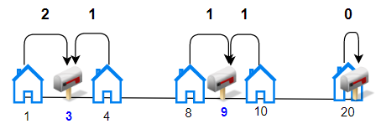

**Input:** houses = [1,4,8,10,20], k = 3

**Output:** 5

**Explanation:** Allocate mailboxes in position 3, 9 and 20.

Minimum total distance from each houses to nearest mailboxes is |3-1| + |4-3| + |9-8| + |10-9| + |20-20| = 5

**Example 2:**

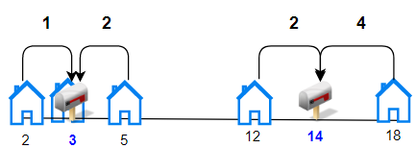

**Input:** houses = [2,3,5,12,18], k = 2

**Output:** 9

**Explanation:** Allocate mailboxes in position 3 and 14.

Minimum total distance from each houses to nearest mailboxes is |2-3| + |3-3| + |5-3| + |12-14| + |18-14| = 9.

**Example 3:**

**Input:** houses = [7,4,6,1], k = 1

**Output:** 8

**Example 4:**

**Input:** houses = [3,6,14,10], k = 4

**Output:** 0

**Constraints:**

* n == houses.length
* 1 <= n <= 100
* 1 <= houses[i] <= 10^4
* 1 <= k <= n
* Array houses contain unique integers.